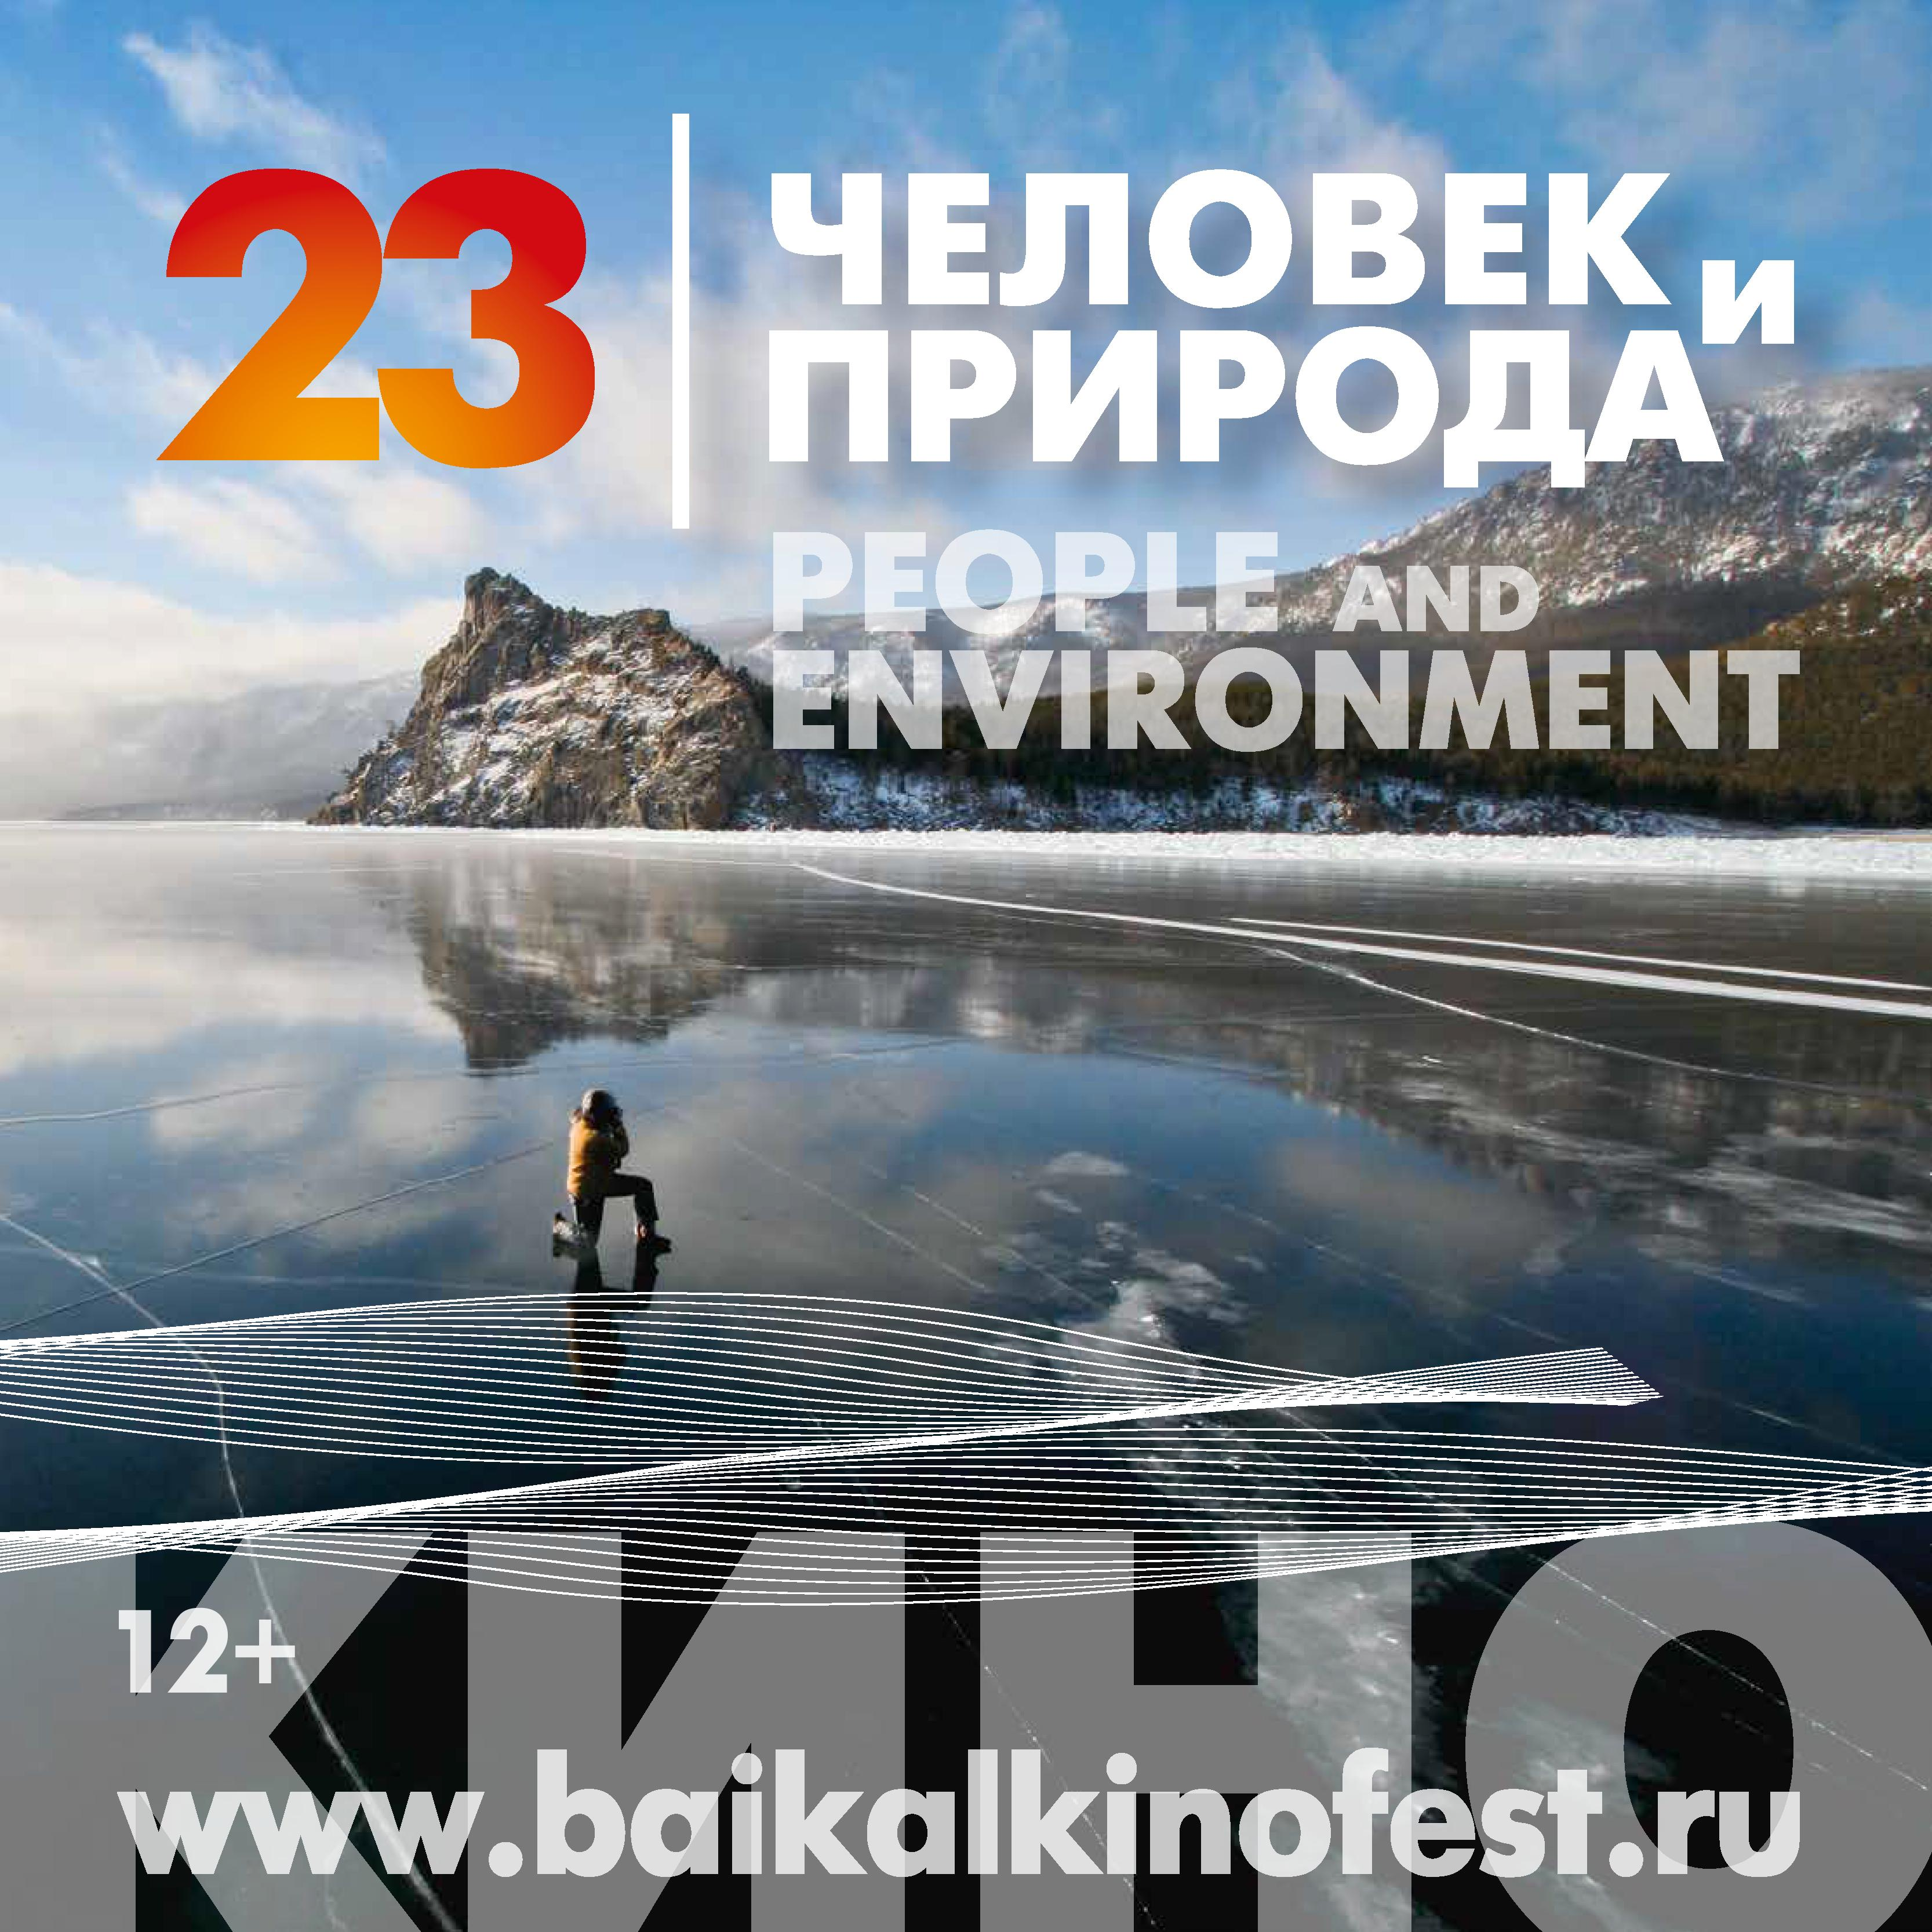

23d Baikal International Film Festival
n.a. Valentin Rasputin

“People and Environment”

Irkutsk, Russia
17-27 September, 2024

Entry Form

Entry form and a copy of a film should be sent by post (to the Festival Direction address: 664056, Russia, Irkutsk, Mukhinoy str, bl.2A) or in electronic view (to e-mail: baikal.festival@gmail.com)
not earlier than 01, February and not later than 10, April 2024

All fields are required to be filled in
Title of film in Russian
Title of film in English
Country of production |  |  |  | Film running time |  |  |  | min.
Year of production ( not earlier than 2022) |  |  |  | Film’s official site
Nomination/category | Documentary film |  | Popular-science film |  | Animated film |  | Feature film
Synopsis of a film or a video in Russian:
Synopsis of a film or a video in English:

Production studio
Name
Address
Telephone |  | Viber/WhatsApp
e-mail |  | Web-site

Copyright owner:
Name of the organization
Address
Mobile phone |  |  | e-mail

Producer |  | e-mail
Script writer
Camera man

FILM DIRECTOR’S INFORMATION
Full name
Date of birth |  | Place of birth
Address
Home phone |  |  | Mobile phone
e-mail: |  |  | Fax
Director’s brief CV:
Filmography: (title of a film, date of production, studio/film company)

Participation in the Festival supposes the giving of the rights for the films’ fragments (10% of a full film’s length, but not more than 3 minutes) to be broadcasted on Russian and foreign TV channels. The same rights are supposed to be given for the internet broadcasting.

Please select the appropriate form of film usage after the Festival:

I agree for non-commercial use of a film or a video and is ready to sign the License Agreement

I agree for commercial screenings of a film or a video and is ready to sign the License Agreement

I do not agree for any use of a film or a video after the Festival.

Please send the following with the Entry form:

Copy of a film or a video on a disc or in electronic view in DVD format (with English subtitles)

Picture of film/video makers and several snapshots from a film /video (in electronic format like jpg or tiff, 300 dpi, not less than 1Mb)

Film trailer on a separate disc or in online view.

Scan copy of distribution certificate (for a film).

Please be informed that the copy of your film or video will be kept in “People and Environment” film festival archive.

Application filling date:

Signature (to be sent by post): ____________________ _____________________________________
Full name of the signee

Links and filled Entry forms will be accepted till 23:59 Moscow time April, 10 2024 if sent to e-mail baikal.festival@gmail.com or you can use the Film Freeway platform.
Note that for the entry form consideration must be provided: copy of a film in electronic form with a link on video platform; photo materials for the catalogue (in electronic form) must contain filmmaker’s photo and film snapshots (in jpg or tiff, 300 dpi, not less than 500 Kb); To be viewed by the selection committee, you must provide: for films in the national language – a copy with English subtitles and editorial scripts (lay-out sheets) in English should be sent obligatory for all participants.
For films in English – a film copy and editorial scripts in English should be sent.
The entry must include: film title, copyright owners/production company, filmmaker name, camera man name, film running time, the year of a film production, nomination, director biography and filmography, film synopsis (70 words). The trailer of the film should be sent too.

Contacts:
e-mail: baikal.festival@gmail.com

Program managers of the festival:
- Documentary and popular-science, feature films – Elena Utrobina, tel. +79148999471;
- Animated films – Polina Stepanova, tel. +7 9994233282;

THANK YOU!

